AMRITA VISHWA VIDYAPEETHAM – CHENNAI CAMPUS
DEPARTMENT OF COMPUTER SCIENCE AND ENGINEERING
23CSE302 – COMPUTER NETWORKS
EXPERIMENT 4
IMPLEMENTATION OF DHCP SERVER
Name: Chetan Kumar G |  | Max Marks (10)
Roll No.: CH.SC.U4CSE24109 | Section: CSE B
Date of Exp: 14 | 07 | 2026 | Date of Submission:14|07|2026

OBJECTIVES:
- Students will gain indepth understanding of how to setup a Server as a DHCP Server
- Students will have exposure to conﬁgure a Router as a DHCP Server

IMPLEMENTATION OF A BASIC DHCP SERVER ON A SINGLE DEVICE

AIM
To configure a DHCP server on a PC-PT device using Cisco Packet Tracer and verify that the client device can obtain an IP address automatically.

SYSTEM AND SOFTWARE REQUIREMENTS
Software – Cisco Packet Tracer

Components used:
- End Devices
  - PC-PT
  - Server -PT
- Connections
  - Copper Cross-over

PROCEDURE
To configure a DHCP server on a network using Cisco Packet Tracer and obtain an IP address automatically, follow these steps:

Step 1: Open Cisco Packet Tracer
1) Launch Cisco Packet Tracer on your computer.

Step 2: Add Devices to the Workspace
- Add one PC:
  - Click on the "End Devices" icon in the bottom left corner.
  - Select "PC" and drag a PC into the workspace.
- Add a server:
  - Click on the "End Devices" icon in the bottom left corner.
  - Select "Server" and drag a server into the workspace.

Step 3: Connect the Devices

- Select the Connection Tool:
  - Click on the "Connections" icon (lightning bolt) in bottom left corner.
- Connect the PC to the server:
  - Click on a PC and then click on the server to connect them with a Copper Cross-Over cable.

Step 4: IP Configuration for Server-PT
- Open the Server, navigate to Config, and Edit FastEthernet0 tab.
- Choose Static to set IP address and subnet mask,

IPv4 Address: 192.168.1.1
Subnet Mask: 255.255.255.0
- Check the box for "Port Status" to bring the interface up.

Step 5: Configure the DHCP Server:

- Click on the Server-PT device to open its configuration window.
- Navigate to the Services tab and Select DHCP from the services list.
- Turn on the DHCP service if it is not already on.
- Configure the DHCP settings:
  - Set the Start IP Address to 192.168.1.2
  - Enter the Subnet Mask as 255.255.255.0
  - Enter Maximum Number of Users as 3
  - Click on Add to save the DHCP pool.

Step 6: Configure the PC-PT to Use DHCP:

- Click on the PC-PT to open its configuration window.
- Navigate to the Desktop tab and then to IP Configuration.
- Select the DHCP option to obtain an IP address automatically via DHCP.

Step 7: Verify the Configuration:

- Return to the Desktop tab of the PC-PT and open the Command Prompt.
- Type ipconfig and press Enter to see the IP address assigned by the DHCP server.
- Type ipconfig /release to release the IP address back to the DHCP pool, disconnect from the network and prepare for obtaining a new IP address.
- Type ipconfig /renew to re-establish network connectivity and get a new IP address after releasing the previous one.

NETWORK TOPOLOGY DIAGRAM

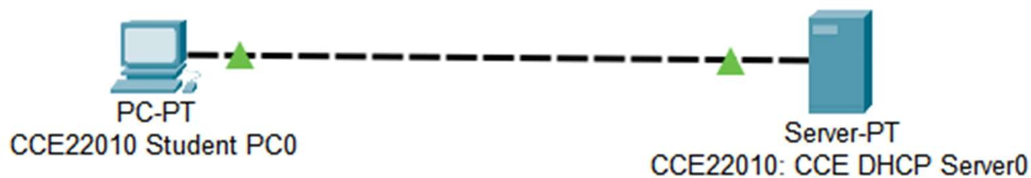
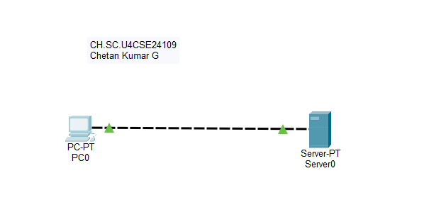

OUTPUT

IP Configuration of DHCP server:
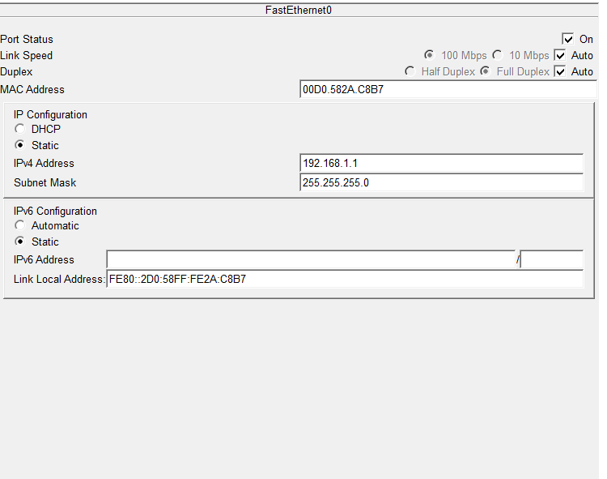

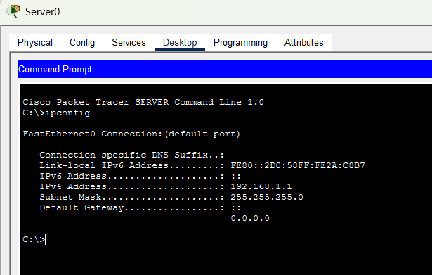
- Configure the DHCP Server:

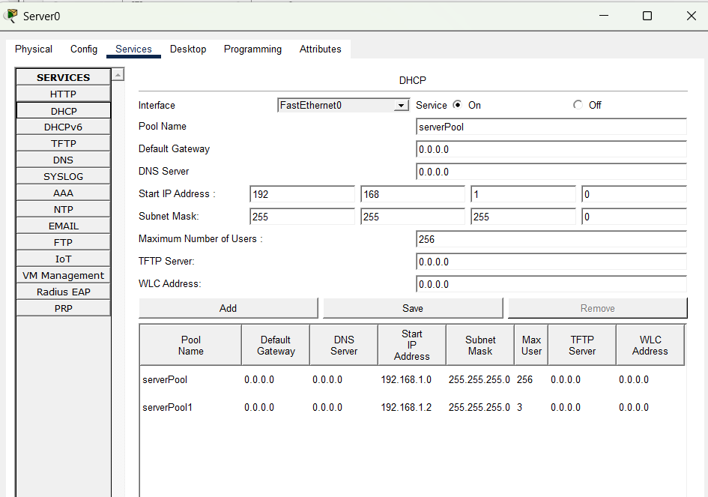

Configure the PC-PT to Use DHCP:

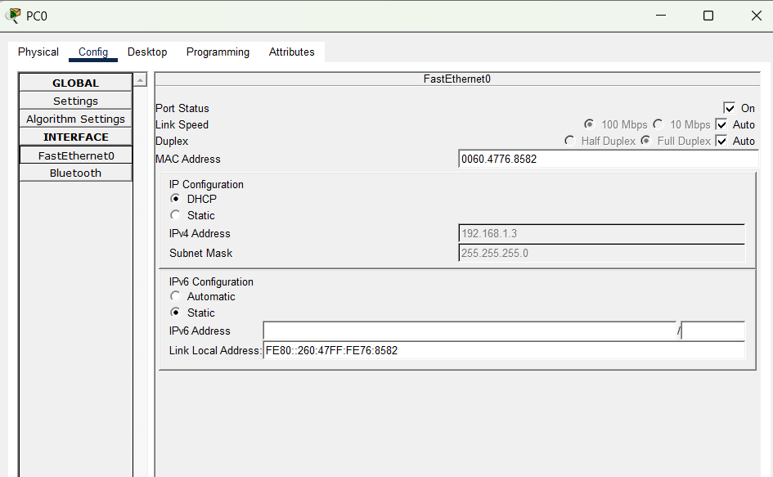
- Verify the Configuration:
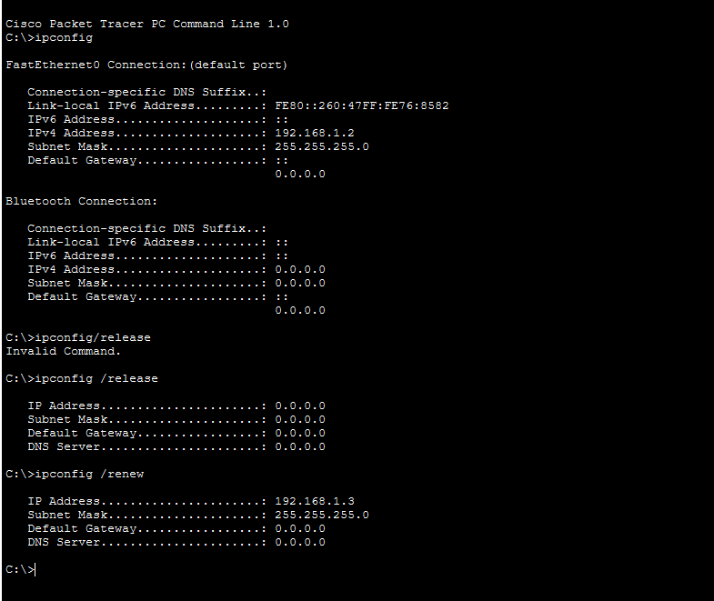

RESULT
The DHCP server was successfully configured on the Server-PT device. The client PC automatically obtained a valid IP address, subnet mask, and other network parameters from the DHCP server. The ipconfig /release and ipconfig /renew commands successfully released and renewed the IP address, confirming that the DHCP server was functioning correctly and dynamically assigning IP addresses to the client device.

- First IP Configuration: obtain an IP address automatically via DHCP for Faculty PC.

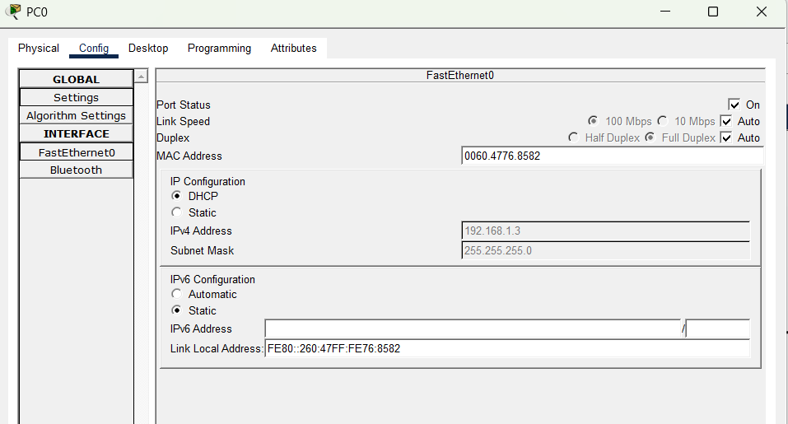
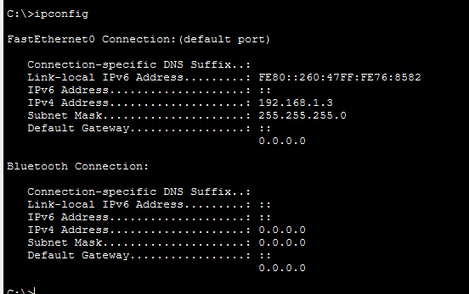

- Release of IP address back to the DHCP pool using ipconfig /release and re- establish network connectivity to get a new IP address using ipconfig /renew:

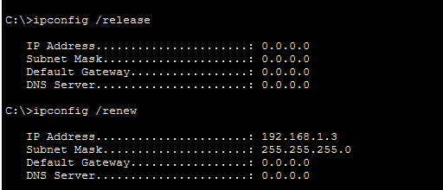

- The new IP address is auto-updated in the IP configuration tab of Faculty PC:

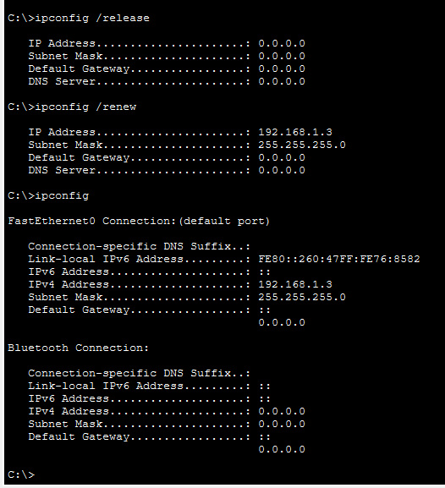

INFERENCE

The experiment demonstrated the successful configuration of a DHCP server on a Server-PT device. The client PC automatically obtained a valid IP address, subnet mask, and other network parameters without manual configuration. The use of ipconfig /release and ipconfig /renew verified that the DHCP server could dynamically allocate and reassign IP addresses, simplifying network administration.

IMPLEMENTATION OF A DHCP SERVER ON DEVICES IN THE SAME NETWORK

AIM
To configure a DHCP server on a network using Cisco Packet Tracer and verify that the client device can obtain an IP address automatically.

SYSTEM AND SOFTWARE REQUIREMENTS
Software – Cisco Packet Tracer

Components used:
    - End Devices
      - 5 PC-PTS
      - Server -PT
    - Network Devices
- Switch 2950-24
    - Connections
      - Copper Straight-Through

PROCEDURE
To configure a DHCP server on a network using Cisco Packet Tracer and obtain an IP address automatically, follow these steps:

Step 1: Open Cisco Packet Tracer
1) Launch Cisco Packet Tracer on your computer.

Step 2: Add Devices to the Workspace
- Add four PCs:
  - Click on the "End Devices" icon in the bottom left corner.
  - Select "PC" and drag four PCs into the workspace.
- Add a server:
  - Click on the "End Devices" icon in the bottom left corner.
  - Select "Server" and drag a server into the workspace.

- Add a Switch:
  - Click on the "Switches" icon in the bottom left corner.
  - Select a switch (2950-24) and drag it into the workspace.

Step 3: Connect the Devices
- Select the Connection Tool:
  - Click on the "Connections" icon (lightning bolt) in bottom left corner.
- Connect the PCs to the Switch:
  - Click on a PC and then click on the switch to connect them with a copper straight-through cable.
  - Repeat the process for the four PCs.
- Connect the Switch to the Server:
  - Click on the switch and then click on the server to connect them with a copper straight-through cable.

Step 4: IP Configuration for Server-PT
- Open the Server, navigate to Config, and Edit FastEthernet0 tab.
- Choose Static to set IP address and subnet mask,

IPv4 Address: 192.168.1.1
Subnet Mask: 255.255.255.0
- Check the box for "Port Status" to bring the interface up.

Step 5: Configure the DHCP Server:
- Click on the Server-PT device to open its configuration window.
- Navigate to the Services tab and Select DHCP from the services list.
- Turn on the DHCP service if it is not already on.
- Configure the DHCP settings:
  - Set the Start IP Address to 192.168.1.2
  - Enter the Subnet Mask as 255.255.255.0
  - Enter Maximum Number of Users as 4
  - Click on Add to save the DHCP pool.

Step 6: Configure the PC-PT to Use DHCP:
- Click on the PC-PT to open its configuration window.
- Navigate to the Desktop tab and then to IP Configuration.
- Select the DHCP option to obtain an IP address automatically via DHCP.

Step 6: Verify the Configuration:
- Return to the Desktop tab of the PC-PT and open the Command Prompt.
- Type ipconfig and press Enter to see the IP address assigned by the DHCP server.
- Type ipconfig /release to release the IP address back to the DHCP pool, disconnect from the network and prepare for obtaining a new IP address.
- Type ipconfig /renew to re-establish network connectivity and get a new IP address after releasing the previous one.

NETWORK TOPOLOGY DIAGRAM
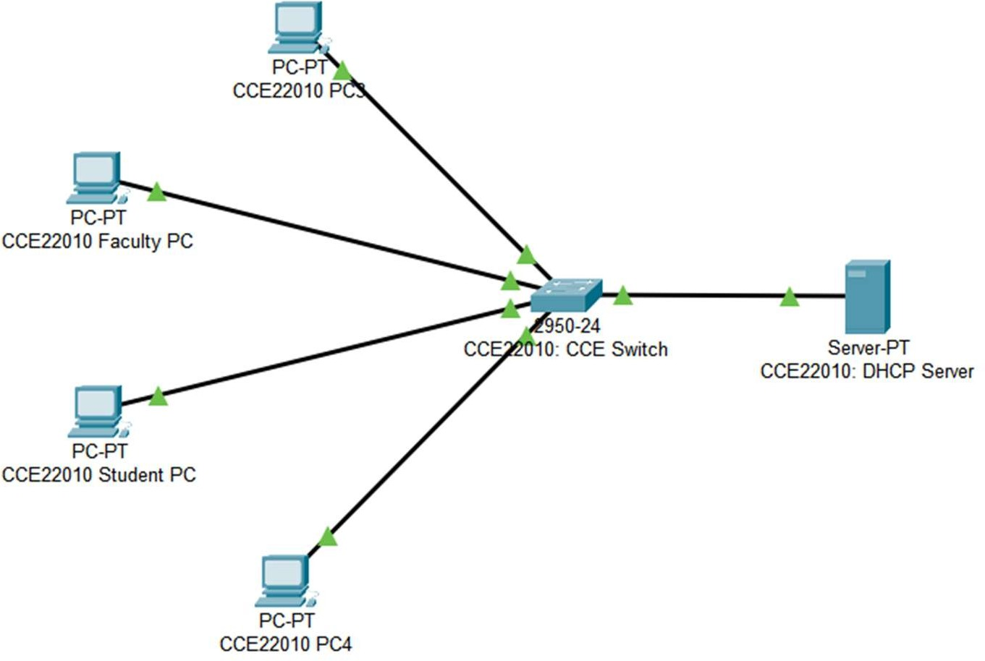
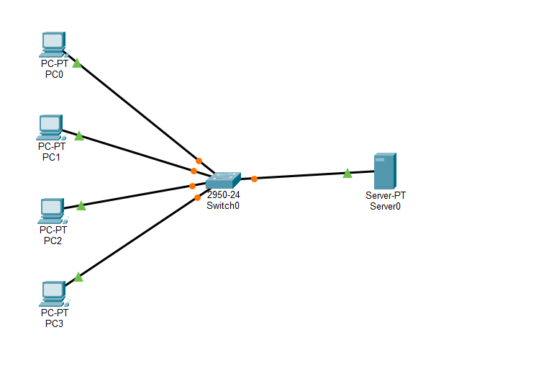
OUTPUT

IP Configuration of DHCP server:

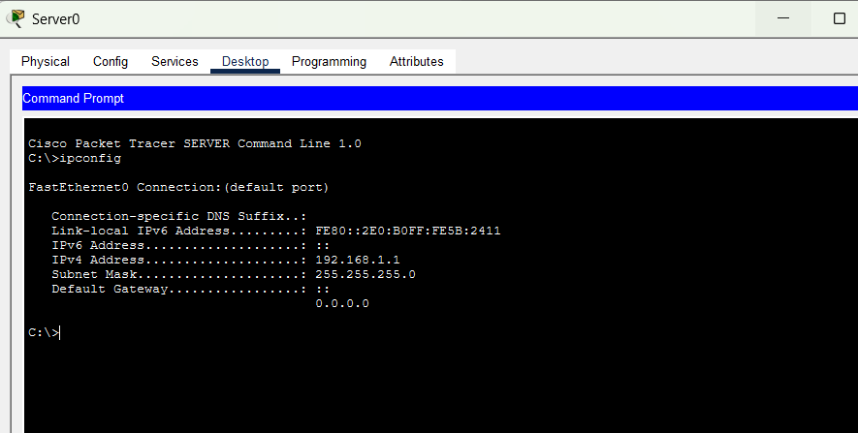
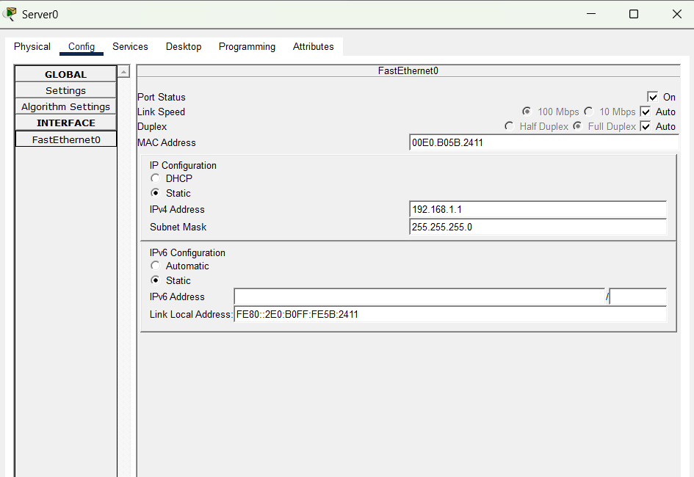
- Configure the DHCP Server:

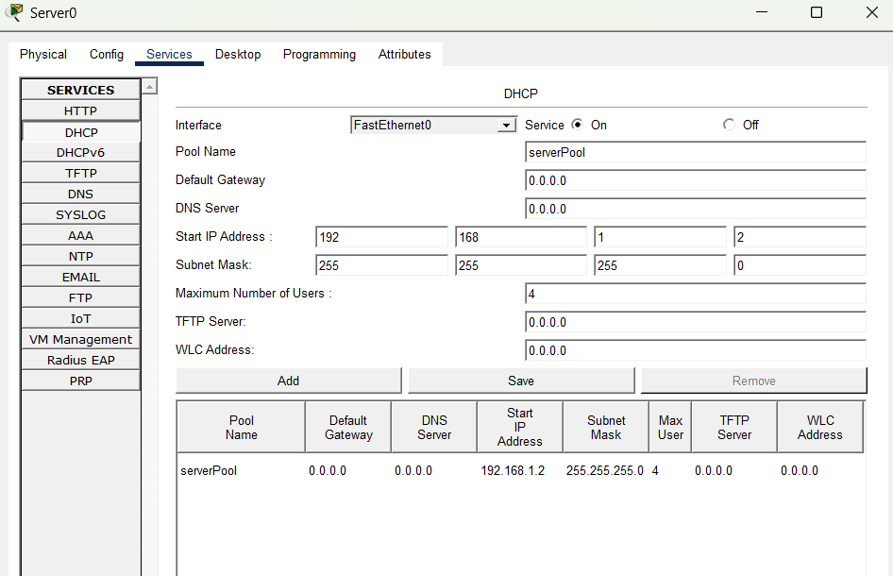

Configure the PC-PTs to Use DHCP:

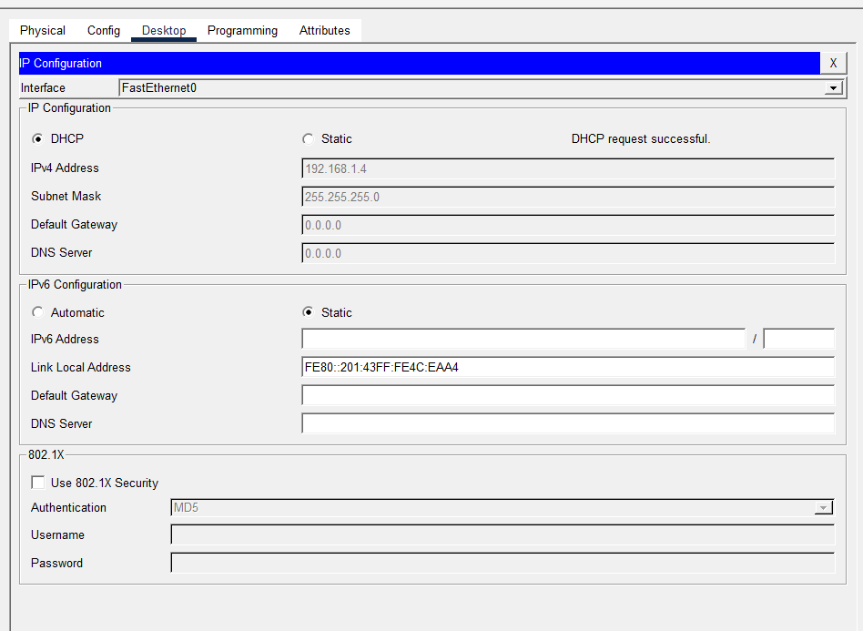
- Verify the Configuration:

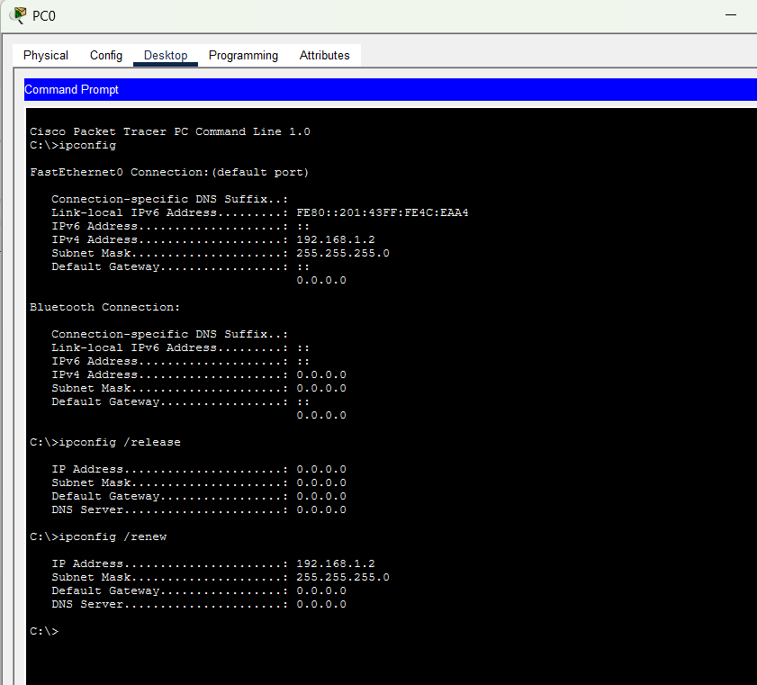

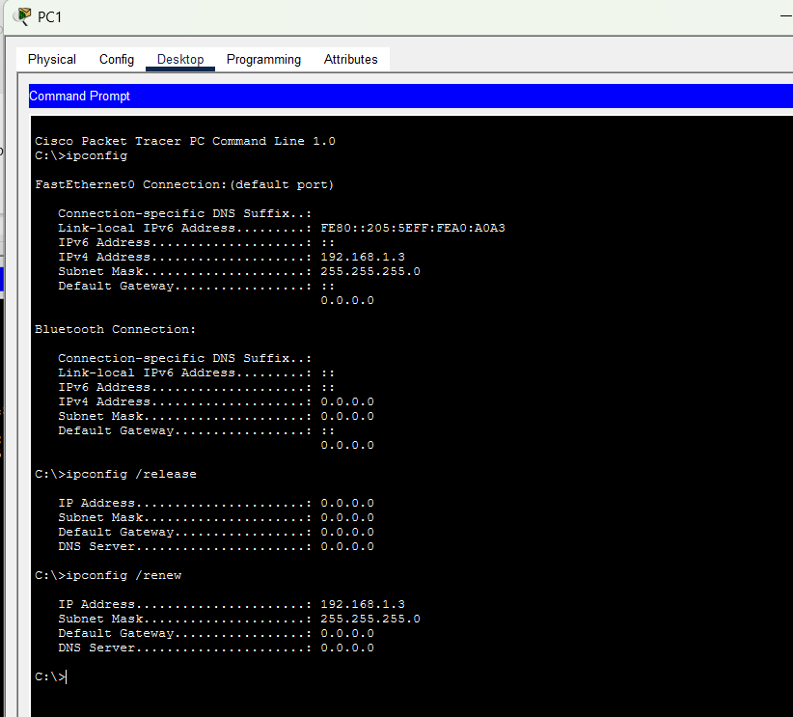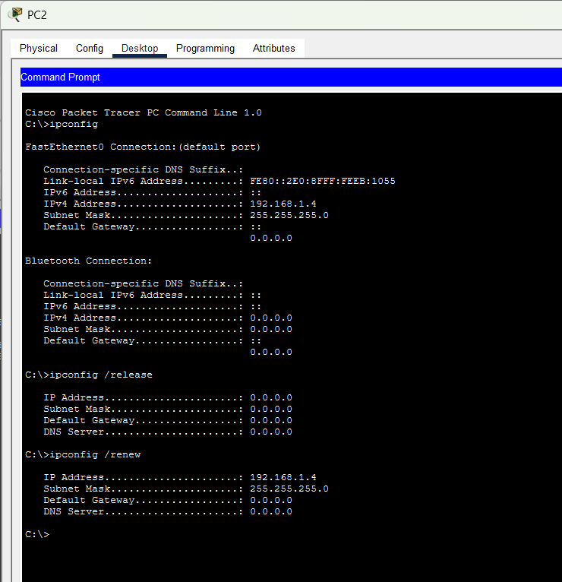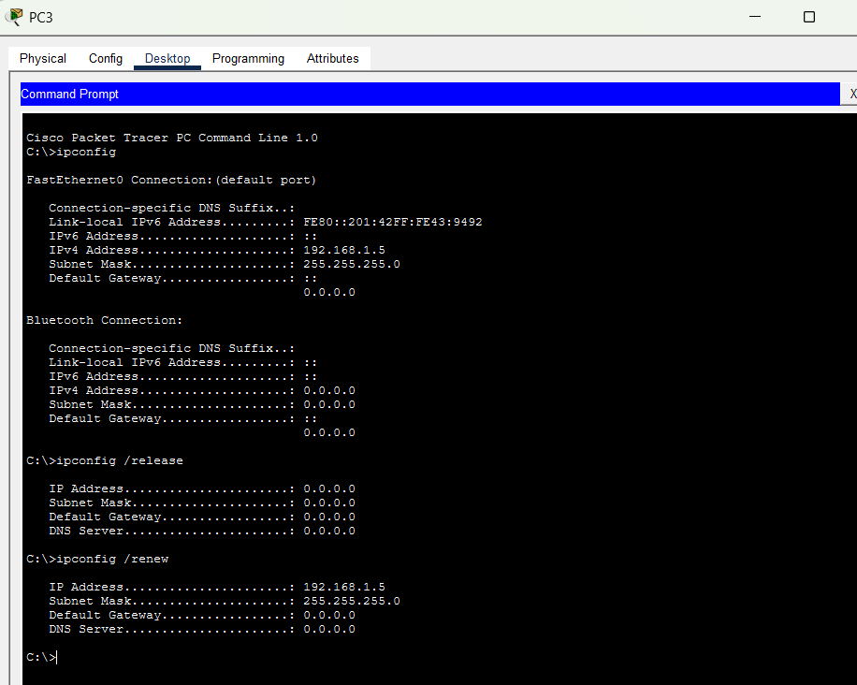

RESULT

- First IP Configuration: obtain an IP address automatically via DHCP for Faculty PC.


- Release of IP address back to the DHCP pool using ipconfig /release and re-establish network connectivity to get a new IP address using ipconfig/renew:


INFERENCE:
The experiment demonstrated the successful configuration of a DHCP server to dynamically assign IP addresses to multiple client devices within the same network. All connected PCs received unique IP addresses automatically, eliminating the need for manual IP configuration. This experiment highlights the efficiency, scalability, and reliability of DHCP in simplifying network administration and reducing IP address configuration errors.

CONFIGURING ROUTER AS DHCP SERVER FOR ONE END DEVICE

AIM
To configure a Cisco router as a DHCP server for a PC-PT device using Cisco Packet Tracer and verify that it assigns IP addresses dynamically to the connected devices.

SYSTEM AND SOFTWARE REQUIREMENTS
Software – Cisco Packet Tracer

Components used:
    - End Devices
      - PC-PT
    - Network Devices
      - Router 2911
    - Connections
      - Copper Straight-Through

PROCEDURE
To configure a Cisco router as a DHCP server on a network using Cisco Packet Tracer and obtain an IP address automatically, follow these steps:

Step 1: Open Cisco Packet Tracer
1) Launch Cisco Packet Tracer on your computer.

Step 2: Add Devices to the Workspace
- Add one PCs:
  - Click on the "End Devices" icon in the bottom left corner.
  - Select "PC" and drag a PC into the workspace.
- Add a Router:
  - Click on the "End Devices" icon in the bottom left corner.
  - Select " Router " and drag a router (2901 series) into the workspace.

Step 3: Connect the Devices
- Select the Connection Tool:
  - Click on the "Connections" icon (lightning bolt) in bottom left corner.
- Connect the PC to the router:
  - Click on a PC and then click on the router to connect them with a Copper Straight-Through cable.

Step 4: Configure IP Address of Router
- Click on the router and navigate to the Config tab.
- Select the interface connected to the PC (e.g., GigabitEthernet0/0).
- Set the IP address and subnet mask:

IP Address: 192.168.1.1
Subnet Mask: 255.255.255.0
- Check the box for "Port Status" to bring the interface up.

Step 5: Configure the Router as DHCP Through Command Line Interface
- Select the router, navigate to CLI
- Enter privileged EXEC mode by typing:

enable
- Enter global configuration mode by typing:

configure terminal
- Exclude the specified range of IP addresses (192.168.1.1 to 192.168.1.5) from being assigned by the DHCP server:

ip dhcp excluded-address 192.168.1.1 192.168.1.5
- Create a new DHCP pool named "pool1" and enter DHCP pool configuration mode:

ip dhcp pool pool1
- Define the network range for the DHCP pool.

network 192.168.1.0 255.255.255.0
- Specify the DNS server IP address (192.168.1.10) that will be provided to DHCP clients.

dns-server 192.168.1.10
- Sets the default gateway (router) IP address (192.168.1.1) for DHCP clients:

default-router 192.168.1.1
- Exit the DHCP pool configuration mode

exit

Step 6: Verify the Configuration and obtain IP address for the PC Through graphical-user interface:
- On the PC, go to the Desktop tab, open the IP Configuration, and set it to DHCP.
- Verify that the PC obtains an IP address from the router.

Through Command Line Interface:
- Type ipconfig /release to release the IP address back to the DHCP pool, disconnect from the network and prepare for obtaining a new IP address.
- Type ipconfig /renew to re-establish network connectivity and get a new IP address from the DHCP pool after releasing the previous one.

NETWORK TOPOLOGY DIAGRAM

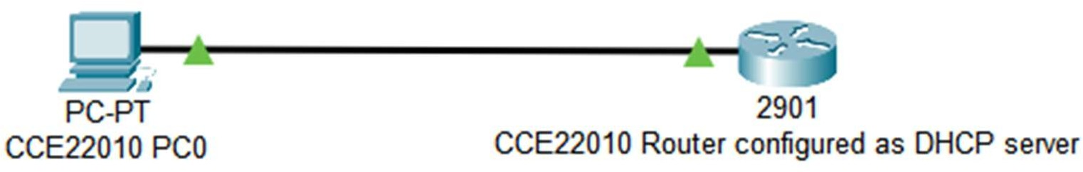

OUTPUT

- Configure IP Address of Router:

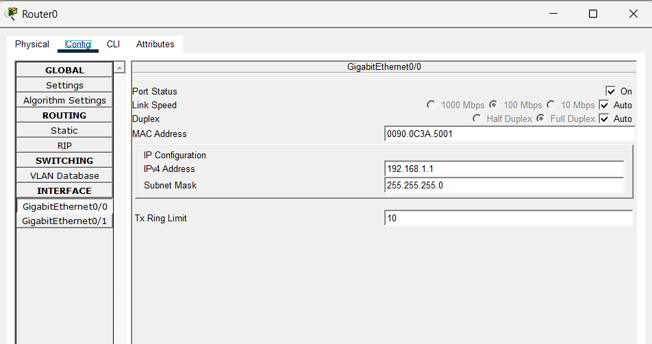
- Configure the Router as DHCP Through Command Line Interface

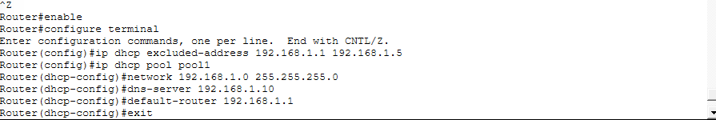

- Verify Configuration:

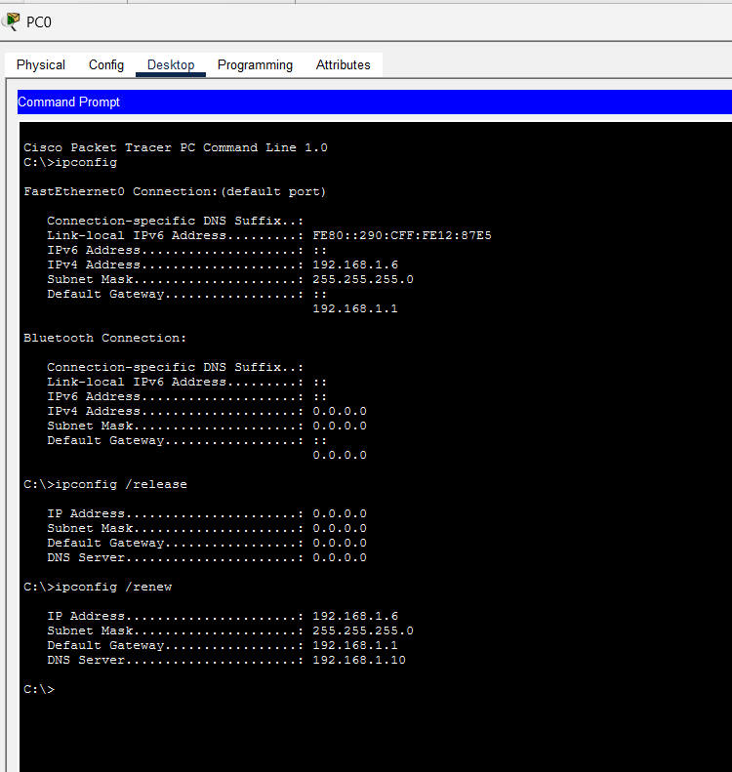

RESULT

- First IP Configuration: obtain an IP address automatically via DHCP for Faculty PC.

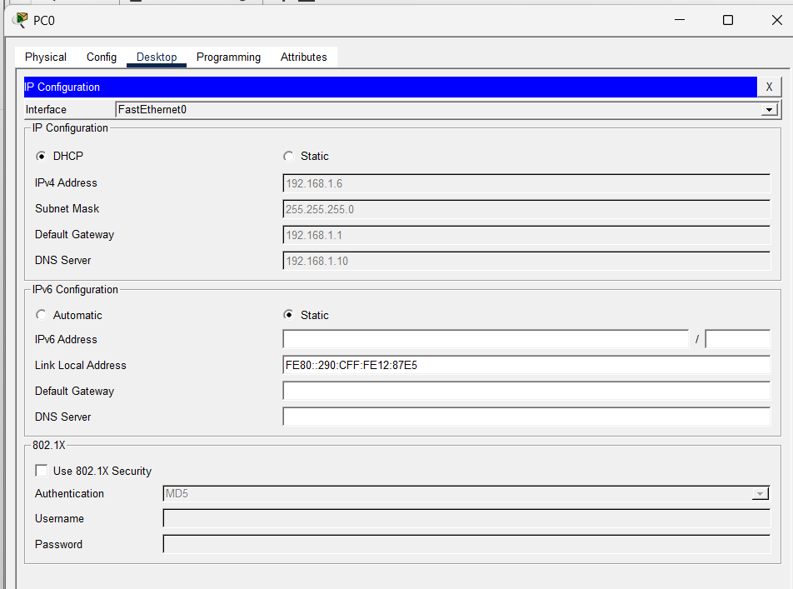

- Release of IP address back to the DHCP pool using ipconfig /release and re- establish network connectivity to get a new IP address using ipconfig /renew:

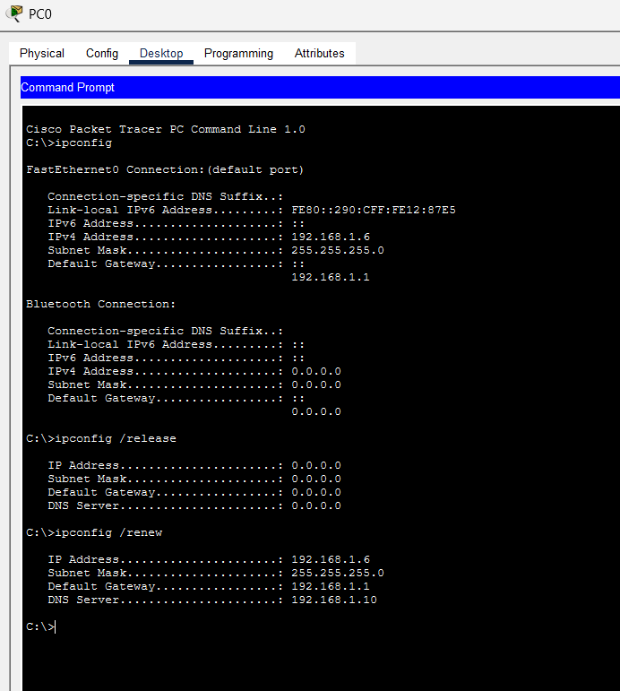

- The new IP address is auto-updated in the IP configuration tab of Faculty PC:


INFERENCE

The experiment demonstrated that a Cisco router can effectively function as a DHCP server by dynamically assigning IP addresses and other network parameters to a connected client. The PC successfully obtained its IP configuration automatically, and the IP lease could be released and renewed without errors. This experiment highlights the practical use of router-based DHCP services in simplifying network configuration and ensuring efficient IP address management.

CONFIGURING ROUTER AS DHCP SERVER ON DEVICES IN THE SAME NETWORK

AIM
To configure a Cisco router as a DHCP server on a network using Cisco Packet Tracer and verify that it assigns IP addresses dynamically to the connected devices.

SYSTEM AND SOFTWARE REQUIREMENTS
Software – Cisco Packet Tracer

Components used:
    - End Devices
      - 5 PC-PT
    - Network Devices
      - Router 2911
- Switch 2950-24
    - Connections
      - Copper Straight-Through
      - Console cable

PROCEDURE
To configure a Cisco router as a DHCP server on a network using Cisco Packet Tracer and obtain an IP address automatically, follow these steps:

Step 1: Open Cisco Packet Tracer
1) Launch Cisco Packet Tracer on your computer.

Step 2: Add Devices to the Workspace
- Add Five PCs:
  - Click on the "End Devices" icon in the bottom left corner.
  - Select "PC" and drag five PCs into the workspace.

- Add a Router:
  - Click on the "End Devices" icon in the bottom left corner.
  - Select " Router " and drag a router (2901 series) into the workspace.
- Add a Switch:
  - Click on the "Switches" icon in the bottom left corner.
  - Select a switch (2950-24) and drag it into the workspace.

Step 3: Connect the Devices

- Select the Connection Tool:
  - Click on the "Connections" icon (lightning bolt) in bottom left corner.
- Connect the PC to the switch:
  - Click on a PC and then click on the switch to connect them with a Copper Straight-Through cable.
  - Repeat the process for the five PCs.
- Connect the Switch to the Router:
  - Click on the switch and then click on the router to connect them with a copper straight-through cable.
- Connect a PC to the router:
  - Click on a PC and then click on the router to connect them with a console cable.

Step 4: Configure IP Address of Router

- Click on the router and navigate to the Config tab.
- Select the interface connected to the PC (e.g., GigabitEthernet0/0).
- Set the IP address and subnet mask:

IP Address: 192.168.1.1
Subnet Mask: 255.255.255.0
- Check the box for "Port Status" to bring the interface up.

Step 5: Configure the Router as DHCP Through Command Line Interface

- Select the router, navigate to CLI
- Enter privileged EXEC mode by typing:

enable

- Enter global configuration mode by typing:

configure terminal
- Exclude the specified range of IP addresses (192.168.1.1 to 192.168.1.5) from being assigned by the DHCP server:

ip dhcp excluded-address 192.168.1.1 192.168.1.5
- Create a new DHCP pool named "pool1" and enter DHCP pool configuration mode:

ip dhcp pool pool1
- Define the network range for the DHCP pool.

network 192.168.1.0 255.255.255.0
- Specify the DNS server IP address (192.168.1.10) that will be provided to DHCP clients.

dns-server 192.168.1.10
- Sets the default gateway (router) IP address (192.168.1.1) for DHCP clients:

default-router 192.168.1.1
- Exit the DHCP pool configuration mode

Exit

Step 6: Verify the Configuration and obtain IP address for the PC

Through graphical-user interface:
- On the PC, go to the Desktop tab, open the IP Configuration, and set it to DHCP.
- Verify that the PC obtains an IP address from the router.

Through Command Line Interface:
- Type ipconfig /release to release the IP address back to the DHCP pool, disconnect from the network and prepare for obtaining a new IP address.
- Type ipconfig /renew to re-establish network connectivity and get a new IP address from the DHCP pool after releasing the previous one.

NETWORK TOPOLOGY DIAGRAM

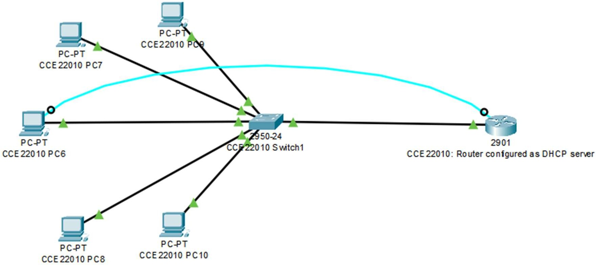
My network
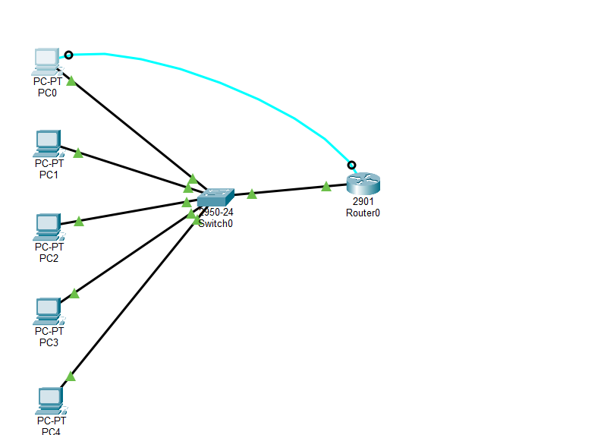
OUTPUT
- Configure IP Address of Router:

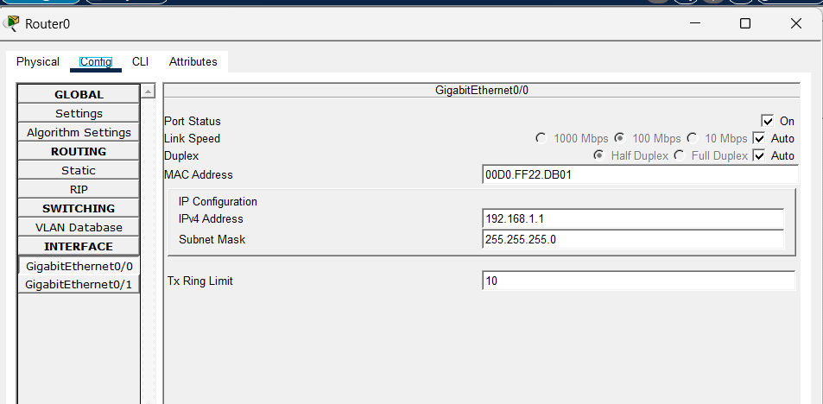

- Configure the Router as DHCP Through Command Line Interface

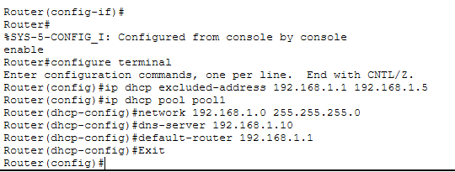
- Access and Configure the Router from PC terminal using console cable:

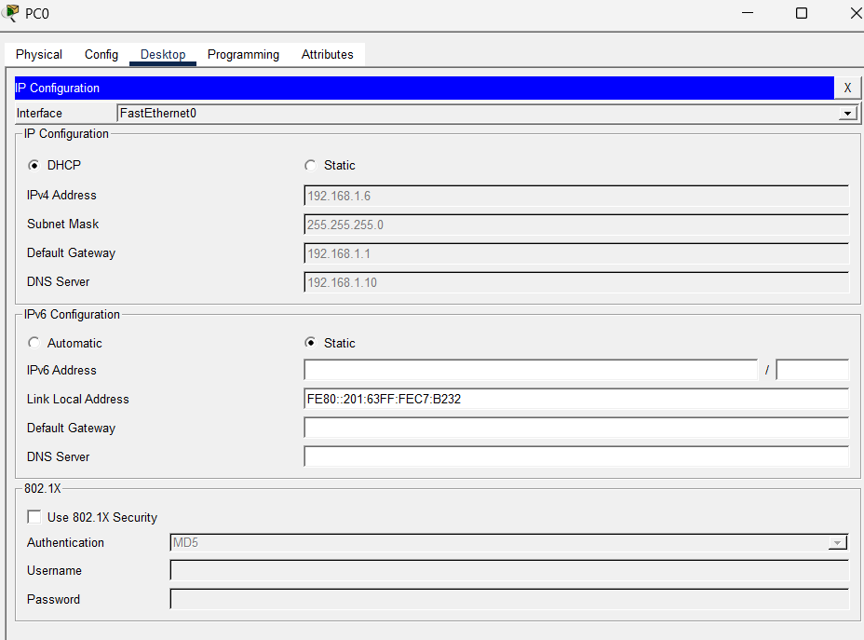

- Verify Configuration through any PC:

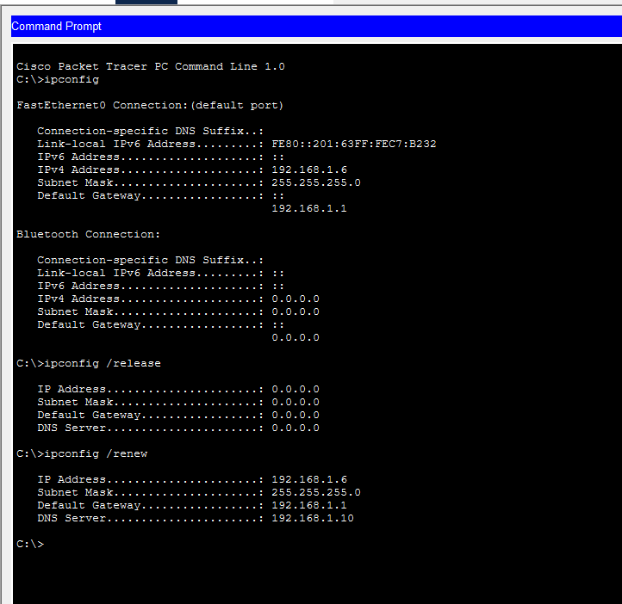

RESULT
We successfully configured a Cisco router to act as a DHCP server. The router dynamically assigned IP addresses to the connected devices within the defined IP range, ensuring efficient IP address management in the network.

- First IP Configuration: obtain an IP address automatically via DHCP for Faculty PC.



- Release of IP address back to the DHCP pool using ipconfig /release and re- establish network connectivity to get a new IP address using ipconfig /renew:



INFERENCE

The experiment demonstrated that a Cisco router can successfully function as a DHCP server for multiple devices connected through a switch. All client PCs automatically received unique IP addresses, subnet masks, default gateway, and DNS information from the configured DHCP pool. The successful verification of IP assignment and network connectivity confirmed that the router efficiently managed dynamic IP allocation, simplifying network administration and ensuring reliable communication among all devices in the networ

CONFIGURATION OF ROUTER AS DHCP SERVER AND IMPLEMENATION OF A WEB SERVER IN A NETWORK

AIM
To configure a DHCP server on a Cisco router for assigning IP addresses dynamically to the connected devices and to implement a web server to access a webpage from connected devices within the network using Cisco Packet Tracer.

SYSTEM AND SOFTWARE REQUIREMENTS
Software – Cisco Packet Tracer

Components used:
  - End Devices
    - 5 PC-PT
    - Server-PT
  - Network Devices
    - Router 2911
- Switch 2950-24
  - Connections
    - Copper Straight-Through
    - Console cable

PROCEDURE

To configure a Cisco router as a DHCP server on a network using Cisco Packet Tracer and obtain an IP address automatically and to implement a web server to access a webpage from connected devices within the network, follow these steps:

Step 1: Open Cisco Packet Tracer
1) Launch Cisco Packet Tracer on your computer.

Step 2: Add Devices to the Workspace
- Add Five PCs:
  - Click on the "End Devices" icon in the bottom left corner.
  - Select "PC" and drag five PCs into the workspace.
- Add a server:
  - Click on the "End Devices" icon in the bottom left corner.
  - Select "Server" and drag a server into the workspace.
- Add a Router:
  - Click on the "End Devices" icon in the bottom left corner.
  - Select " Router " and drag a router (2901 series) into the workspace.
- Add a Switch:
  - Click on the "Switches" icon in the bottom left corner.
  - Select a switch (2950-24) and drag it into the workspace.

Step 3: Connect the Devices
- Select the Connection Tool:
  - Click on the "Connections" icon (lightning bolt) in bottom left corner.
- Connect the PC to the switch:
  - Click on a PC and then click on the switch to connect them with a Copper Straight-Through cable.
  - Repeat the process for the five PCs.
- Connect the Server to the switch:
  - Click on a Server and then click on the switch to connect them with a Copper Straight-Through cable.
- Connect the Switch to the Router:
  - Click on the switch and then click on the router to connect them with a copper straight-through cable.
- Connect a PC to the router:
  - Click on a PC and then click on the router to connect them with a console cable.

Step 4: IP Configuration
- Router IP configuration:
  - Click on the router and navigate to the Config tab.
  - Select the interface connected to the PC (e.g., GigabitEthernet0/0).
  - Set the IP address and subnet mask:

IP Address: 192.168.1.1
Subnet Mask: 255.255.255.0
  - Check the box for "Port Status" to bring the interface up.

- Server IP configuration:
  - Click on the Server and navigate to the Config tab.
  - Select the interface connected to the PC (e.g., FastEthernet0/0).
  - Select Static configuration and Set the IP address and subnet mask:

IP Address: 192.168.1.2
Subnet Mask: 255.0.0.0
  - Check the box for "Port Status" to bring the interface up.

Step 5: Configure the Router as DHCP Through Command Line Interface:

- Select the router, navigate to CLI
- Enter privileged EXEC mode by typing:

enable
- Enter global configuration mode by typing:

configure terminal
- Exclude the specified range of IP addresses (192.168.1.1 to 192.168.1.5) from being assigned by the DHCP server:

ip dhcp excluded-address 192.168.1.1 192.168.1.5
- Create a new DHCP pool named "pool1" and enter DHCP pool configuration mode:

ip dhcp pool pool1
- Define the network range for the DHCP pool.

network 192.168.1.0 255.255.255.0
- Specify the DNS server IP address (192.168.1.10) that will be provided to DHCP clients.

dns-server 192.168.1.10
- Sets the default gateway (router) IP address (192.168.1.1) for DHCP clients:

default-router 192.168.1.1
- Exit the DHCP pool configuration mode

Exit

Step 6: Web Server Configuration:

- Click on the Server-PT device to open its configuration window.
- Navigate to Services, open HTTP, and ensure the service is ON.
- Make any necessary changes to the webpage by editing the index.html.
- Navigate to the Config tab and Edit the global settings
- Name the server (ex: Amrita Web Server)

- Configure the GatewayDNS IPv4 settings:
- Select Static configuration and set the default gateway and DNS server IP address as follows,

Default Gateway: 192.168.1.2
DNS Server: 192.168.1.10

Step 7: Verify the Configuration and obtain IP address for the PC Through graphical-user interface:
- On the PC, go to the Desktop tab, open the IP Configuration, and set it to DHCP.
- Verify that the PC obtains an IP address from the router.

Through Command Line Interface:
- Type ipconfig /release to release the IP address back to the DHCP pool, disconnect from the network and prepare for obtaining a new IP address.
- Type ipconfig /renew to re-establish network connectivity and get a new IP address from the DHCP pool after releasing the previous one.

Step 8: Verify the web service
- On the PC, go to the Desktop tab, open the Web Browser .
- Enter the server's IP address in the URL bar to access the webpage hosted on the web server.

NETWORK TOPOLOGY DIAGRAM
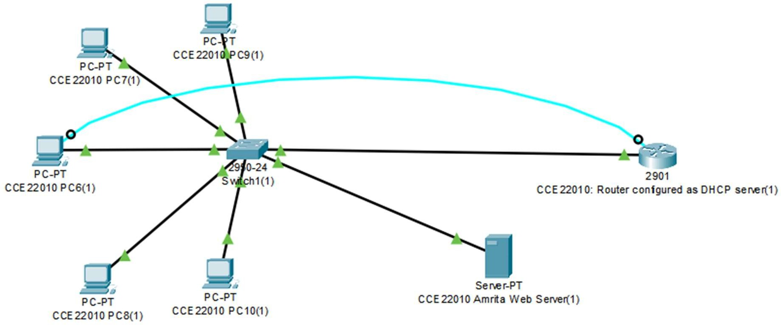

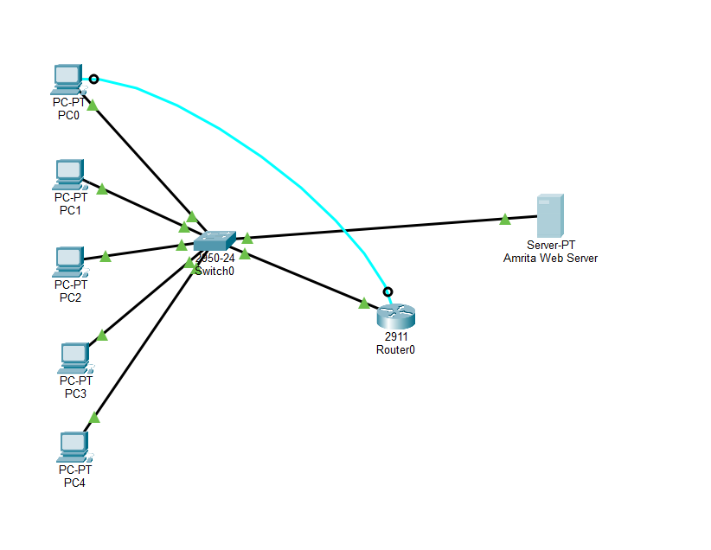
OUTPUT
- Configure IP Address of Router:

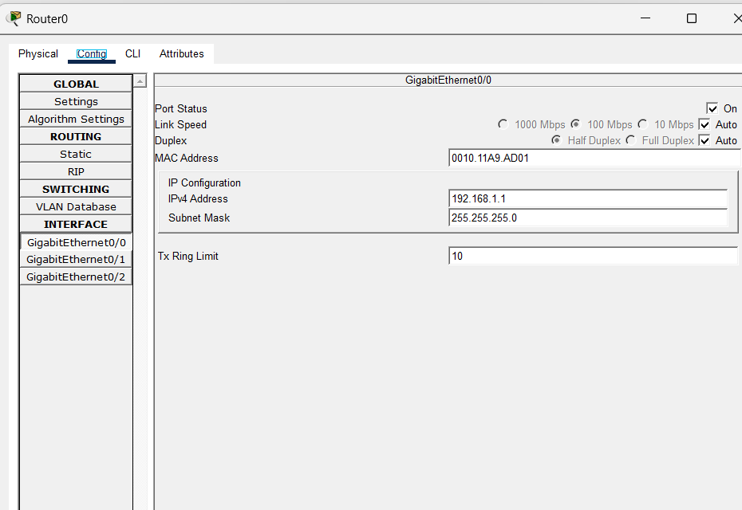

- Configure IP address of Server:
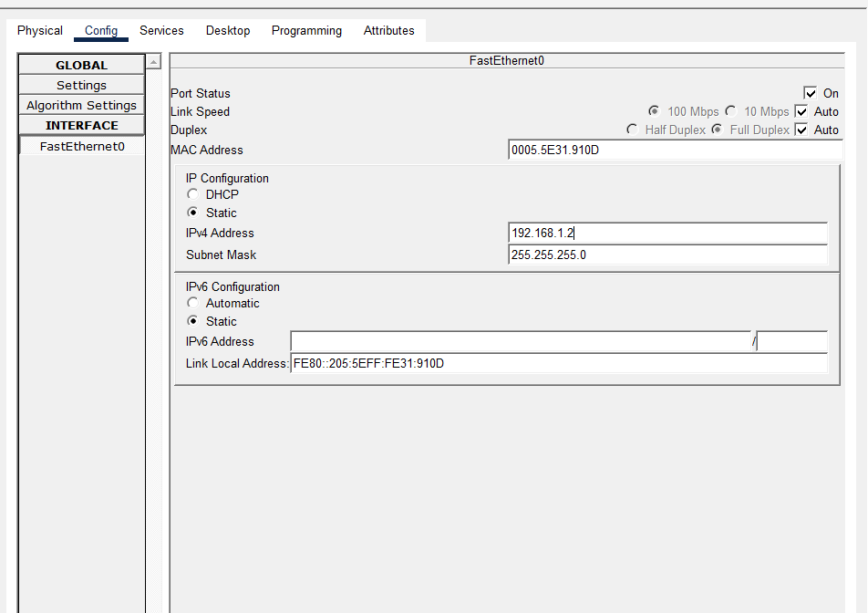

- Configure the Router as DHCP Through Command Line Interface:

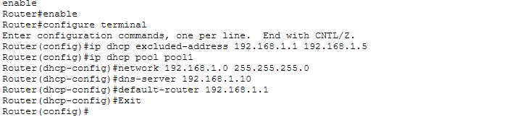
- Webpage: Edit and save the changes made to the webpage

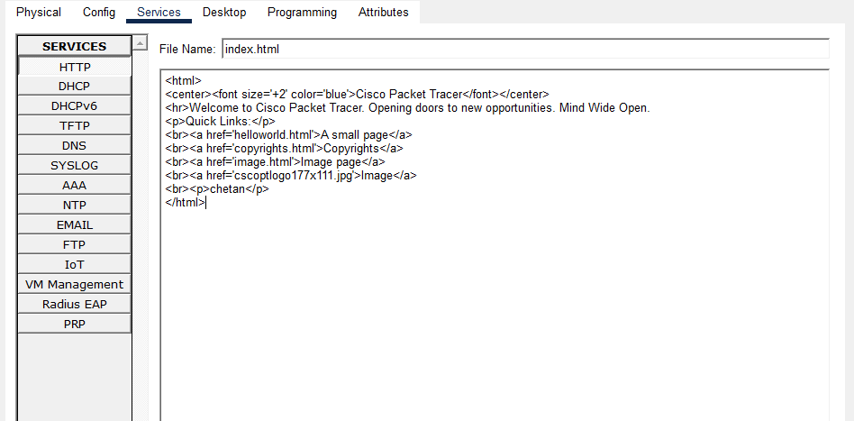

- Web Server Configuration:

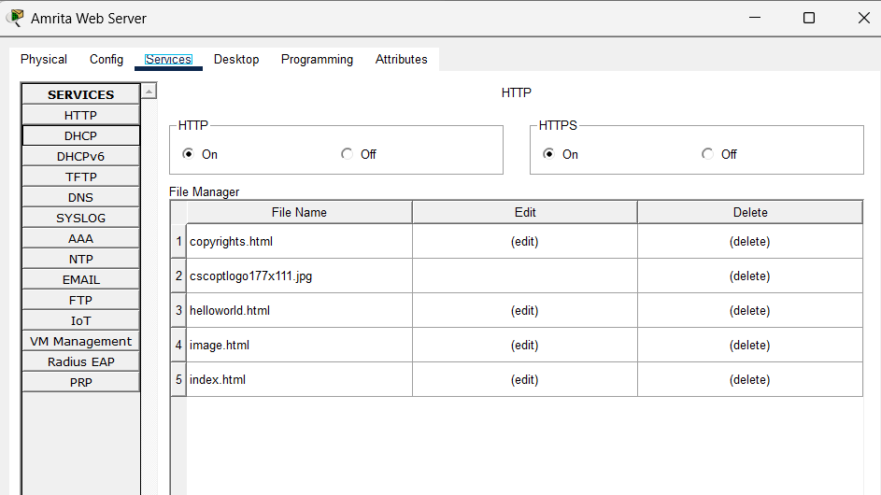
- Verify the Configuration and obtain IP address on any PC:



- Verify the web server access:
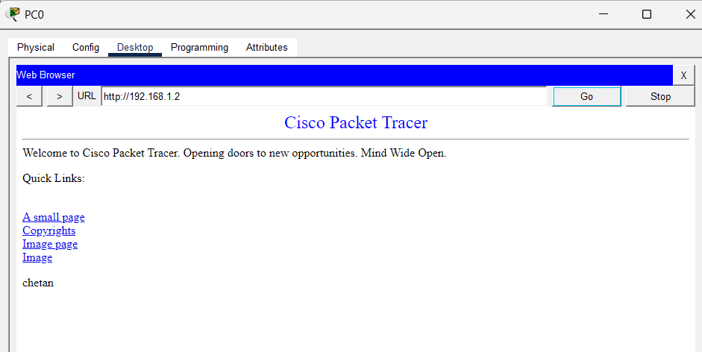

RESULT

We successfully configured a Cisco router to act as a DHCP server. The router dynamically assigned IP addresses to the connected devices within the defined IP range, and implemented a web server to access a webpage from connected devices within the network, ensuring efficient IP address management in the network.
- First IP Configuration: obtain an IP address automatically via DHCP for Faculty PC.

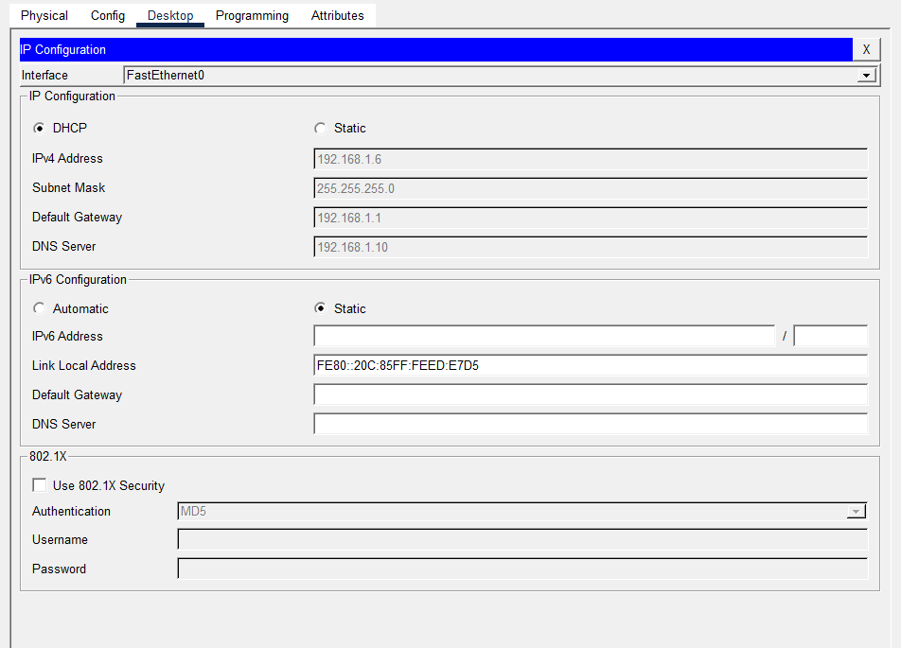

- Release of IP address back to the DHCP pool using ipconfig /release and re-establish network connectivity to get a new IP address using ipconfig

/renew:

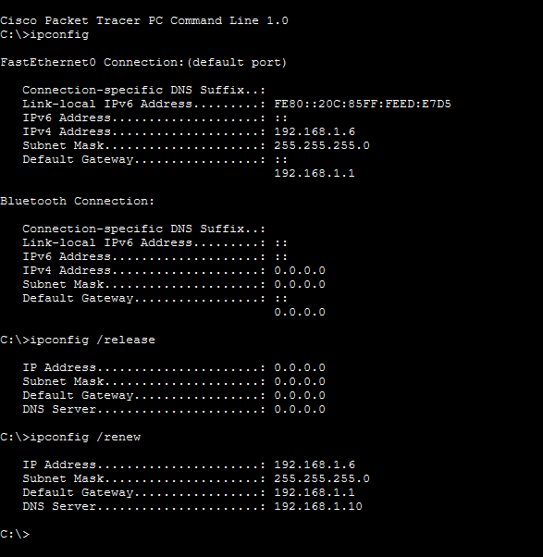
- Access of webpage from the connected devices in the network:



INFERENCE
Configuring a Cisco router as a DHCP server and implementing a web server within a network using Cisco Packet Tracer highlights essential aspects of dynamic IP address allocation and web service accessibility.
This setup involves multiple end devices, including five PCs and a server, connected through a switch to a 2911 router, demonstrating scalable network architecture. The router's DHCP configuration ensures that all connected devices receive IP addresses dynamically, streamlining network management and reducing manual configuration errors. By connecting the server to the switch and configuring it as a web server, the network allows all devices to access a webpage hosted on the server, showcasing integrated network services. This experiment underscores the importance of combining DHCP for efficient IP management with web server implementation for providing network services, illustrating the practical application of these concepts in managing and utilizing network resources effectively.

Lab Scenario: Dynamic IP Allocation for a University Department Network

Scenario Title: "Automating IP Address Assignment in the Computer Science Department"

Background:
The Computer Science Department of a university has recently upgraded its lab infrastructure. There are 50 new client computers that need to connect to the university network. The network administrator wants to avoid manually configuring IP addresses on each machine and instead use a DHCP (Dynamic Host Configuration Protocol) server to automatically assign IP addresses, subnet masks, default gateways, and DNS server details.
You have been assigned the task of setting up and testing a DHCP server in this environment.

Objective:
- Configure a DHCP server on a designated machine or router.
- Ensure that all client machines in the network receive dynamic IP configuration.
- Test and verify successful communication between clients and the network.

Lab Tasks:

Task 1: DHCP Server Configuration
- Set up a DHCP server using either:
  - A dedicated DHCP service (e.g., on a Linux server), OR
  - A simulated router in Cisco Packet Tracer.
- Configure the DHCP server with:
  - IP address range (scope): 192.168.10.100 to 192.168.10.150
  - Subnet mask: 255.255.255.0
  - Default gateway: 192.168.10.1
  - DNS server: 8.8.8.8
Q1: Provide a screenshot or console output showing the configured DHCP scope.
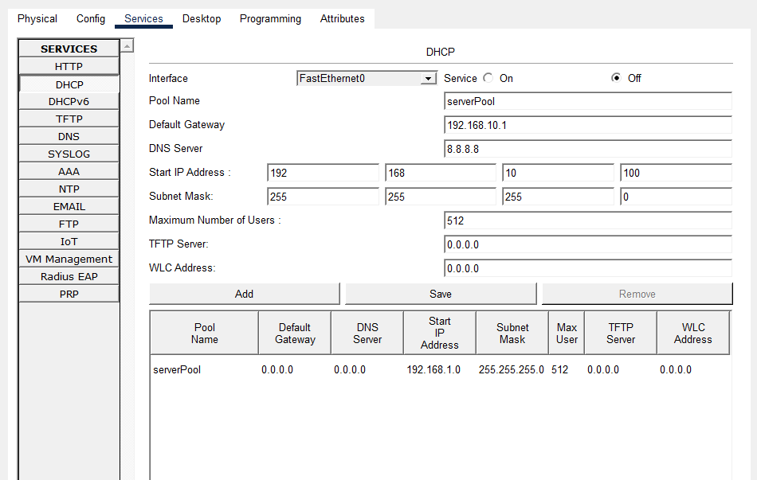
  - IP address range (scope): 192.168.10.100 to 192.168.10.150
  - Subnet mask: 255.255.255.0
  - Default gateway: 192.168.10.1
  - DNS server: 8.8.8.8
  - DHCP sever configured

Task 2: Client Setup and Verification
- Configure at least three client PCs to obtain IP addresses automatically (DHCP).
- Check and record the IP addresses received by the clients.
Q2: What IP address, subnet mask, gateway, and DNS were assigned to each client?
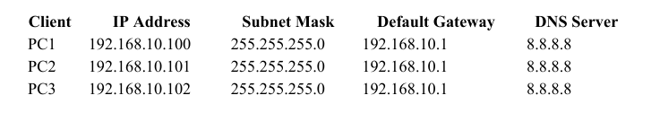
- Test the connection between clients using ping.
Q3: Were the clients able to successfully communicate with each other and the gateway?
Yes. All client PCs successfully communicated with one another and with the default gateway using the ping command. This confirmed that the DHCP configuration and network connectivity were functioning correctly.

Task 3: Simulate DHCP Lease Expiry (Optional Extension)
- Reduce the lease time to a short period (e.g., 1 minute).
- Observe and document how and when the client requests a renewal.
Q4: What behavior did you observe when the lease expired? How did the client behave?
When the DHCP lease expired, the client automatically attempted to renew its IP address by contacting the DHCP server. If the server was available, the client received a renewed lease and continued using the same or a newly assigned IP address without requiring manual intervention. This ensured uninterrupted network connectivity.

Task 4: Troubleshooting Scenario
A client PC is not receiving an IP address from the DHCP server. Diagnose and resolve the issue.
Q5: What were the possible causes, and how did you fix them?

Possible Causes:
• DHCP service was disabled.
• Incorrect DHCP pool configuration.
• Router or server interface was administratively down.
• Wrong cable connections.
• Client configured with a static IP instead of DHCP.
• DHCP address pool was exhausted.

Resolution:
• Enabled the DHCP service.
• Corrected the DHCP pool settings.
• Brought the router/server interface up using no shutdown.
• Verified all physical connections.
• Configured the client to obtain its IP address automatically via DHCP.
• Renewed the client's IP address using ipconfig /release and ipconfig /renew

